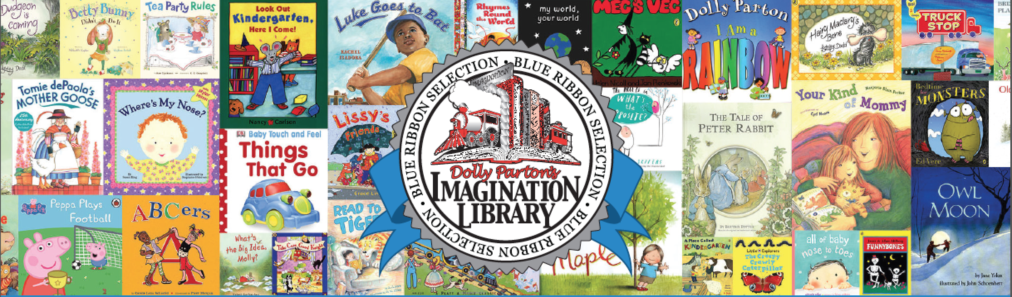

What Is Dolly Parton’s Imagination Library?

Dolly Parton’s Imagination Library is…FREE!

It sounds almost too simple to be true, but by reading regularly with your children during their preschool years, you are giving them the biggest boost toward a successful education they will ever get.

Dolly Parton’s Imagination Library will help you read with your child. There are many reasons parents do not read with their child, but we can eliminate one of them. Every child will have books of their own, at no cost to you, thanks to Friends of the Philipsburg Library, The Ranch at Rock Creek and Dolly Parton.

Each month a new, carefully selected book will be mailed in your child’s name directly to your home. He/she can look forward to new and exciting reading adventures from Dolly Parton’s Imagination Library until he/she turns five years old and as long as you remain a resident of Philipsburg. Should the child move outside of Philipsburg, he/she automatically exits the program.

Who Is Eligible?

Preschool children (birth until their fifth birthday) in Philipsburg, MT 59858

What Are My Responsibilities?

1. Be a resident of Philipsburg, 59858

2. Register your child/children by completing the form below and submitting to The Philipsburg Library or by emailing the registration information to phl5030@blackfoot.net

3. READ WITH YOUR CHILD

When Will I Receive Books?

Eight to ten weeks after your registration has been received, books will begin arriving at your home and will continue until your child turns five or you move out of Philipsburg.

How Can I Help?

Do you know a preschool child in Philipsburg who is not receiving Dolly Parton’s Imagination Library? Give their parents this form and encourage them to fill it out. Telling them about this FREE program can make a huge difference in their future and the future of our community.

If you or someone you know would like to donate funds to support this gift to our children, donations can be made to The Friends Of The Philipsburg Library (Imagination Library)

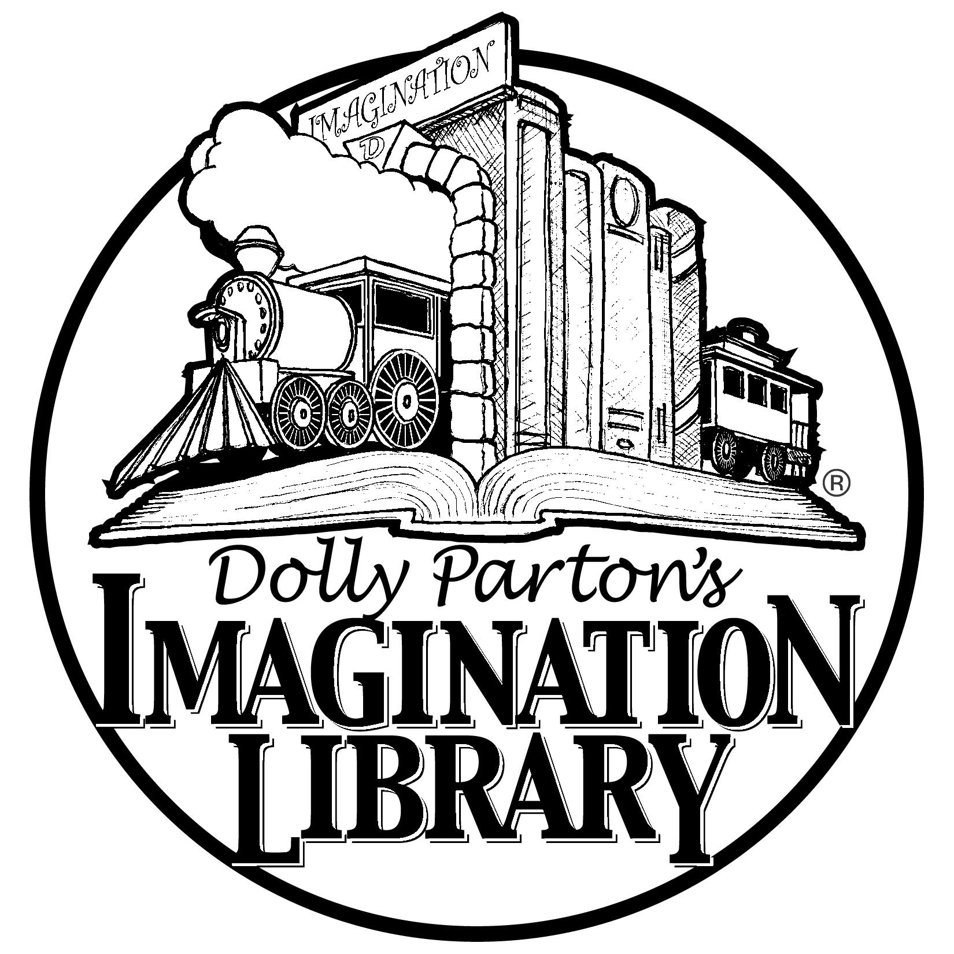

IMAGINATION LIBRARY REGISTRATION FORM

(PLEASE PRINT)

1st Preschool Childs Full Name: ___________________________________
Child’s Date of Birth: __________________________________ Sex: M F

2nd Preschool Childs Full Name: ___________________________________
Child’s Date of Birth: __________________________________ Sex: M F

Parent/Guardian Name: __________________________________________

Childs Home Address: ___________________________________________

___________________________________________

Please return this registration form to The Philipsburg Library or Mail to

Philipsburg Library
PO Box 797
Philipsburg, MT 59858

